The Title Should Clearly Reflect the Research Focus and Originality of the Study. It Must Be Concise, Informative, and Avoid Uncommon Abbreviations.
(Times New Roman, 14 pt, Bol)

Author Name¹*, Author Name², Author Name³
¹Author affiliation including Department, Faculty, University, City, Country
²Author affiliation including Department, Faculty, University, City, Country
³Author affiliation including Department, Faculty, University, City, Country
*Email: author email address (corresponding author)

ABSTRACT
The abstract should provide a clear and concise overview of the entire study and must not exceed 250 words. It should be written in one well-structured paragraph without citations and use clear, accessible, and academic language. The abstract must include five essential elements: the background of the study and the research gap, the research objectives, the methodology, the key findings, and the research implications. It should briefly explain the context of the research and why the study is necessary, state what the research aims to achieve, describe how the study was conducted, summarize the most important results, and show the significance of those results for theory and practice. The abstract should represent the whole content of the article and enable readers to understand the focus, direction, and contribution of the research without reading the full paper.
Keywords: keyword; keyword; keyword; keyword; keyword(3-5 keywords)
(Keywords should be written in lowercase (except proper nouns), be arranged alphabetically, be separated by commas)

INTRODUCTION
The introduction section serves to establish the foundation and scholarly context of the study. It should begin by outlining the background of the research, explaining the relevance of the topic, and situating the study within its academic and practical contexts. This section must integrate a critical overview of recent and relevant literature, including key theories, concepts, and findings from previous studies, to demonstrate the current state of knowledge in the field.
Through this integrated discussion, authors are expected to clearly articulate the research gap, showing how existing studies are limited, inconclusive, or underexplored, and how the present research addresses these shortcomings. The introduction should also emphasize the original contribution and significance of the study in relation to prior research.
At the end of the section, the research objectives and/or research questions must be stated explicitly and coherently. The entire introduction should be written in a well-developed
paragraph format, presenting ideas logically and cohesively, rather than using bullet points or lists.
The combined Introduction section should account for approximately 15–20% of the total manuscript length, ensuring a balanced synthesis between contextual background, literature engagement, and the formulation of the research focus. The recommended length of the manuscript is 4,000–6,000 words, excluding the abstract, references, and appendices.

METHOD
This section explains clearly and systematically how the study was conducted. It describes the overall research process so that other researchers can understand, evaluate, and replicate the study if necessary. The Method section must be written in an objective and detailed manner, focusing on what was done, how it was done, and why certain procedures were chosen. This section should represent approximately 10–15% of the total length of the manuscript and must be presented in well-developed paragraphs rather than bullet points.
The Method section should consist of several subsections that describe the essential components of the research methodology. These include the research design, participants or data sources, instruments, data collection procedures, and data analysis techniques. Each subsection must provide sufficient detail to ensure transparency and replicability. If established or previously published methods are used, they should be acknowledged by citing relevant references, and only necessary modifications or adaptations should be explained. Repetition of standard procedures that are widely known should be avoided.

Research Design
This subsection describes the type and design of the research, such as quantitative, qualitative, or mixed-methods, and explains the specific approach used (e.g., experimental, survey, case study, or descriptive research). It should clarify the rationale for choosing the design and show how it aligns with the research objectives and questions.

Participants or Data Sources
This subsection explains who or what was involved in the study. It should describe the characteristics of the participants or the nature of the data sources, including the number, selection techniques, setting, and relevant demographic or contextual information that supports the credibility of the research.

Instruments
This subsection presents the tools used to collect the data, such as tests, questionnaires, interview guides, observation checklists, or document analysis forms. It should explain the purpose of each instrument, how it was developed or adapted, and how its validity and reliability were ensured, if applicable.

Data Collection Procedures
This subsection describes the practical steps taken to gather the data. It should be written in a chronological and systematic manner, explaining when, where, and how the data were collected, as well as the roles of the researcher and participants during the process.

Data Analysis Techniques
This subsection explains how the collected data were analyzed. It should specify the statistical methods, qualitative analysis procedures, or coding techniques used and justify why these techniques were appropriate for answering the research questions. The number of subsections may vary depending on the complexity and needs of the research methodology, but all key components must be clearly and sufficiently described to ensure methodological rigor and replicability.

RESULTS
The results section presents the findings obtained from the data analysis and focuses on reporting what was discovered in the study. This section must directly answer the research questions or test the research hypotheses that were stated in the introduction. The results should be presented in an objective and factual manner, showing patterns, trends, or differences found in the data without inserting personal opinions or theoretical explanations.
All findings should be clearly organized and systematically described so that readers can easily understand the outcomes of the analysis. When numerical or categorical data are involved, tables and figures should be used to support and clarify the presentation of results. Each table or figure must be properly numbered, titled, and referred to in the text. The narrative explanation should guide readers in interpreting what is shown in the tables or figures, but it should not restate all the numbers or over-explain the visual data.
This section should avoid excessive interpretation or discussion of meaning, as detailed explanations and theoretical implications belong to the Discussion section. The main purpose of the Results section is to report the findings accurately, concisely, and objectively, ensuring that the presented results are directly connected to the research objectives and can be clearly distinguished from interpretation or evaluation.
Table 1
Title of the table
No. | Column number 1 | Column number 2 | Column number 3 | Column number 4 | Column number 5
1. | Row 1 | Row 1 | Row 1 | Row 1 | Row 1
2. | Row 2 | Row 2 | Row 2 | Row 2 | Row 2
3. | Row 3 | Row 3 | Row 3 | Row 3 | Row 3
4. | Row 4 | Row 4 | Row 4 | Row 4 | Row 4

Figure 1
Title of the figure

Figure 1
Title of the figure
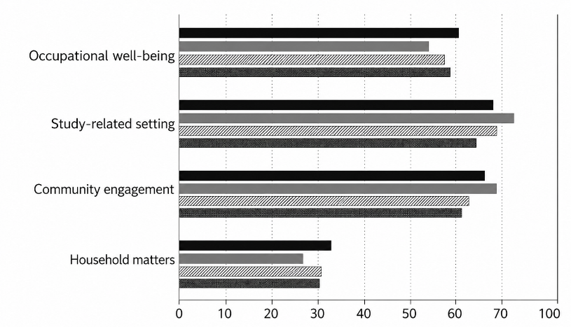

Figure 1
Title of the figure

DISCUSSION
The discussion section interprets the findings and explains their significance in relation to the research objectives. This section should show how the results answer the research questions or test the proposed hypotheses and clarify what the findings mean for the studied phenomenon. Unlike the Results section, which only reports data, the Discussion provides deeper explanation and interpretation of the outcomes.
The discussion should compare the findings with those of previous studies to determine whether the results confirm, extend, or contradict existing research. Similarities should be explained as evidence that supports or strengthens earlier theories and empirical findings, while differences should be analyzed by considering factors such as research context, participants, methods, or instruments used. This comparison helps position the current study within the broader academic literature.
In addition, the discussion must address both theoretical and practical implications. Theoretical implications explain how the findings contribute to the development, refinement, or validation of existing theories or concepts. Practical implications describe how the results can be applied in real situations, such as in teaching practices, curriculum development, policy making, or professional training. The results and discussion sections together should constitute approximately 40–60% of the total manuscript length, reflecting their central role in presenting and interpreting the core contributions of the study.

CONCLUSION
The conclusion should restate the research objectives and briefly summarize the major findings in an integrated way without repeating sentences from the abstract or results. It should highlight the main contributions of the study and explain the theoretical and practical implications of the findings. This section should also acknowledge the limitations of the research and provide recommendations for future studies and practical applications.

AI DECLARATION USE

ACKNOWLEDGEMENTS (IF ANY)

FUNDING STATEMENT (IF APPLICABLE)

REFERENCES
The references section must include all sources cited in the manuscript. A minimum of 30 references is required, with at least 75% published within the last five years. All citations and references must follow APA 7th Edition guidelines, and the use of reference management tools such as Mendeley or Zotero is mandatory. References must be arranged alphabetically, use hanging indentation, and be single-spaced. Each reference should be complete and include a DOI or URL when available to ensure accuracy and easy access to the sources.

Journal Article with DOI
Adinlou, N. A., & Far, L. M. (2014). Self-efficacy and writing strategy use among EFL learners. International Journal of Applied Linguistics & English Literature, 3(4), 221–227. https://doi.org/10.7575/aiac.ijalel.v.3n.4p.221

Journal Article without DOI
Brecht, H. D. (2012). Learning from online video lectures. Journal of Information Technology Education, 11, 227–250. https://eric.ed.gov/?id=EJ990981

Book
Richards, J. C. (2001). Curriculum development in language teaching. Cambridge University Press.

Thesis
Harris, L. (2014). Instructional leadership perceptions and practices of elementary school leaders (Unpublished doctoral dissertation). University of Virginia.

APPENDICES (IF ANY)

General Requirements
Authors must follow the journal’s submission and formatting guidelines carefully. Manuscripts that do not comply may be returned for revision or rejected before the peer-review process. All submissions must be made through the journal’s online system. Each manuscript will be checked using plagiarism-detection software, and papers with a similarity index above 15% must be revised before they can be reviewed.
All manuscripts must be original, research-based articles that have not been published or submitted elsewhere. They must be written in English and prepared in Microsoft Word (DOC/DOCX) format. The recommended length is 4,000–6,000 words, excluding the abstract, references, and appendices. Authors are encouraged to ensure language accuracy by using proofreading tools or professional editing services.

Notes:
For headings system, please follow this guide to show the level of the section headings in your article:
Heading 1: Bold, Centered, Uppercase
Heading 2: Bold, Left-Aligned, Title Case
Heading 3: Bold Italic, Left-Aligned, Title Case
Heading 4: Italic, Indented, sentence case, ending with a period. Text continues on the same line.

IN-TEXT CITATION EXAMPLES (APA 7th)
One author
Richards (2001) argues that language curricula should be context-sensitive.
(Language learning requires systematic planning; Richards, 2001)
Two authors
Taylor and Bogdan (1984) emphasize qualitative inquiry.
(Taylor & Bogdan, 1984)
Three or more authors
Davies et al. (2011) highlight the importance of needs analysis.
(Davies et al., 2011)

